WEFESite Analyst Report: Test Case Case Study

WEFESiteAnalyst is an automatized remote data collection tool for the site-tailored planning of integrated Water-Energy-Food-Environment Systems (iWEFEs). This report presents findings and insights from the analysis of the case study for Test Case. The WEFESite Analyst tool aims to provide valuable information for decision-making and planning related to environmental factors, site suitability, and more. Thank you for using WEFESite Analyst for your case study analysis!

# Satellite Map

The map will be included once we figure out how to export it as an image.

# Terrain

This is an example of how the elevation layer can be exported. Note that the marked central point does not show up using this method.

**Elevation value at location:** 650 meters

# Landuse

The map will be included once we decide on which method to use.

**Cultivated Crops:** It says this gets inserted manually from interview results. Need to figure out how to present this then.

# Soil

|  |  |
| --- | --- |
| Parameter | Value |
| soil organic carbon [dg/kg] | 48.00 |
| bulk density [cg/cm³] | 143.00 |
| cation exchange capacity at pH 7 [mmol(c)/kg] | 146.00 |
| nitrogen content [cg/kg] | 495.00 |

# Hydrology

The map will be included once the bug has been fixed

# Climate

## Solar Irradiance

**Total solar irradiance:** 4058.47 kWh/m^2/a

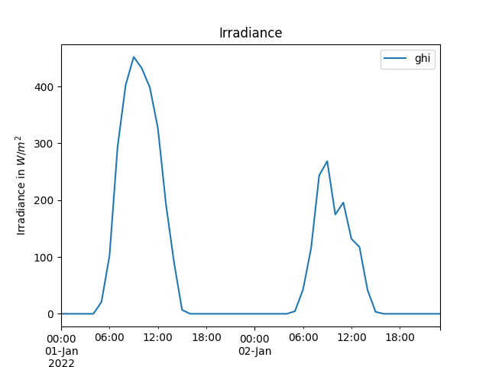

## Windspeed

**Average windspeed:** 4.48 m/s

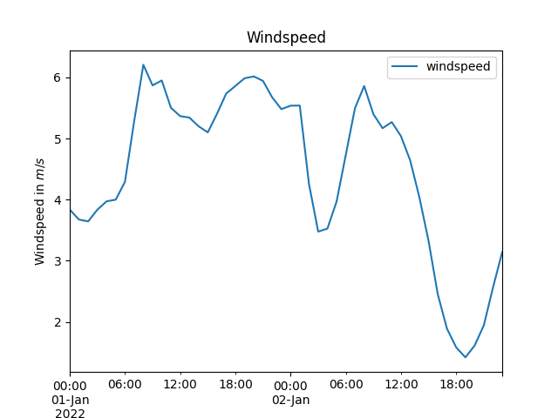

## Precipitation

**Total precipitation:** 2.37 mm

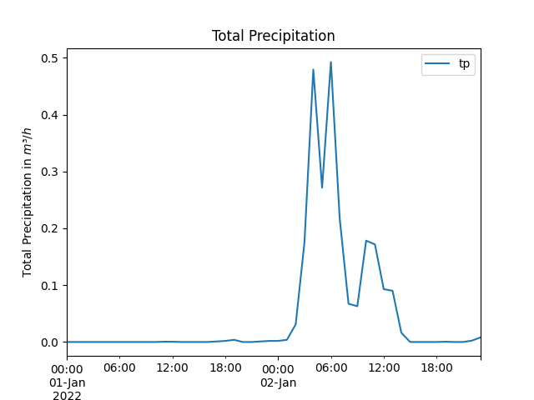

## Temperature

**Average temperature:** 10.21 °C

